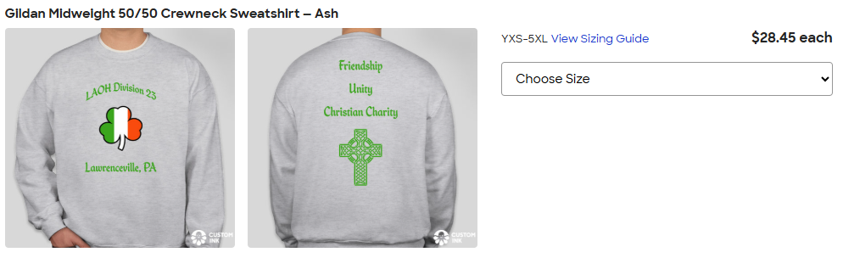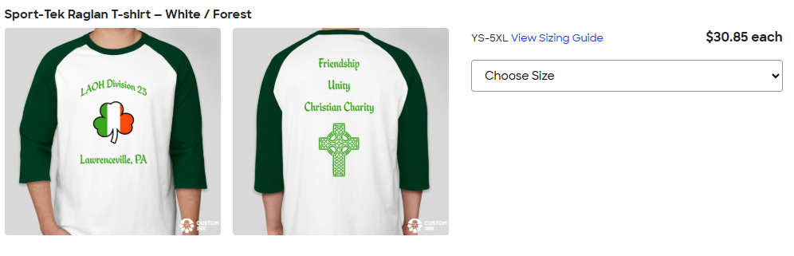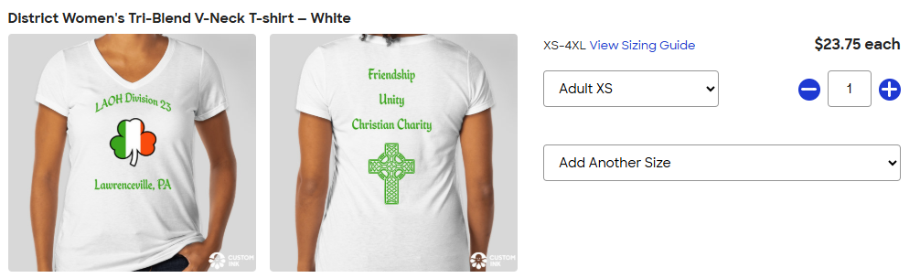
Size QTY Amount
Adult XS ________ __________
Adult S ________ __________
Adult M ________ __________
Adult L ________ __________
Adult XL ________ __________
Adult 2XL ________ (+2.50) __________
Adult 3XL ________ (+3.50) __________
Adult 4XL ________ (+4.50) __________
Total $__________
Size QTY Amount
Adult XS ________ __________
Adult S ________ __________
Adult M ________ __________
Adult L ________ __________
Adult XL ________ __________
Adult 2XL ________ (+2.50) __________
Adult 3XL ________ (+3.50) __________
Adult 4XL ________ (+4.50) __________
Total $_________

Size QTY Amount
Adult XS ________ __________
Adult S ________ __________
Adult M ________ __________
Adult L ________ __________
Adult XL ________ __________
Adult 2XL ________ (+2.50) __________
Adult 3XL ________ (+3.50) __________
Adult 4XL ________ (+4.50) __________
Total $_________

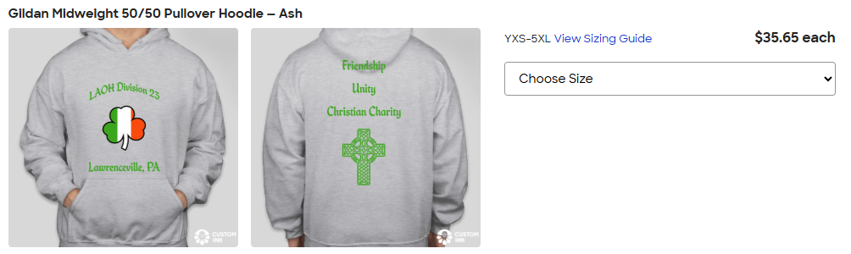
Size QTY Amount
Adult XS ________ __________
Adult S ________ __________
Adult M ________ __________
Adult L ________ __________
Adult XL ________ __________
Adult 2XL ________ (+2.50) __________
Adult 3XL ________ (+3.50) __________
Adult 4XL ________ (+4.50) __________
Total $__________ _____________
Total $_________

